**APPLIED STATITICS LAB**

**WEEK-1**

NAME: SRIJITH U

REG NO : 22BCE8916

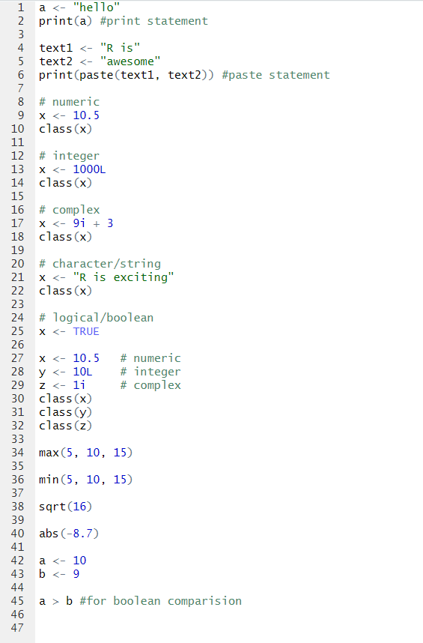

Output:

